**Task: 17 Launch Linux EC2 instances in two regions using a single Terraform file.**

1. **Installed terraform:**

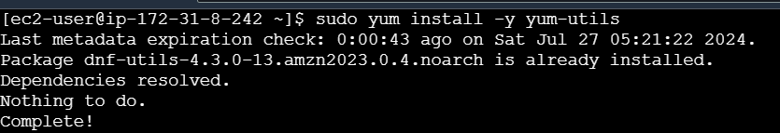

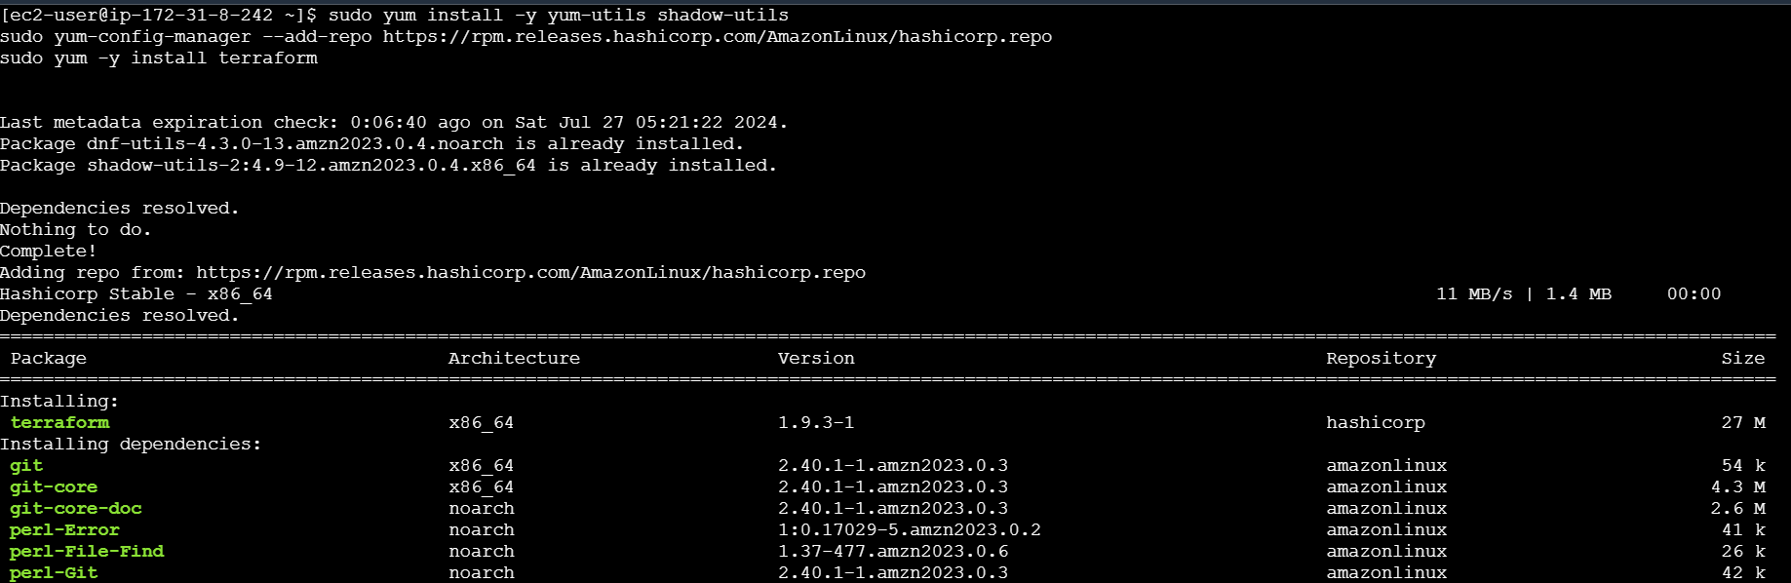

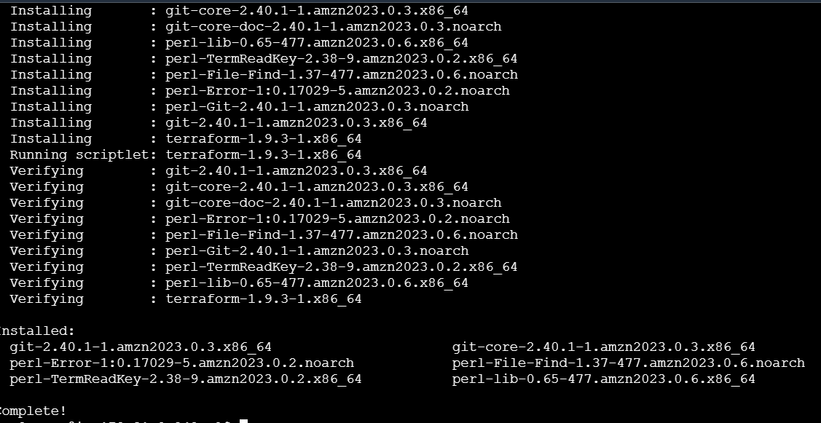

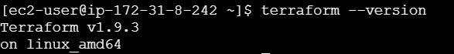

1. **Create a directory for write terraform file:**

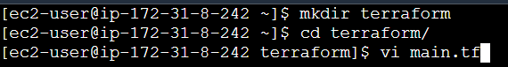

1. **Main.tf file:**

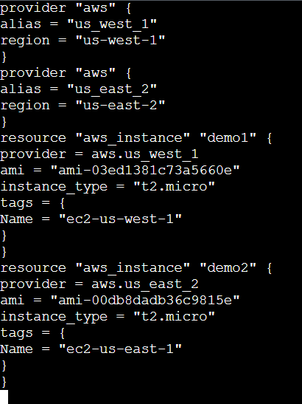

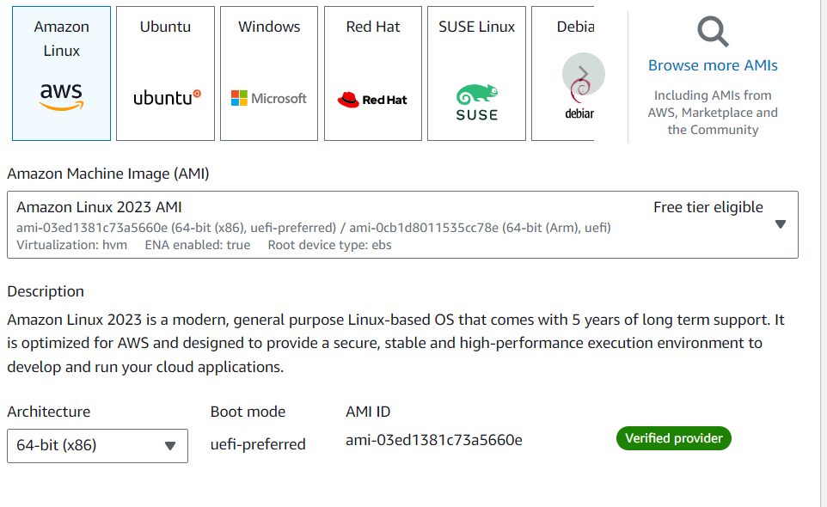

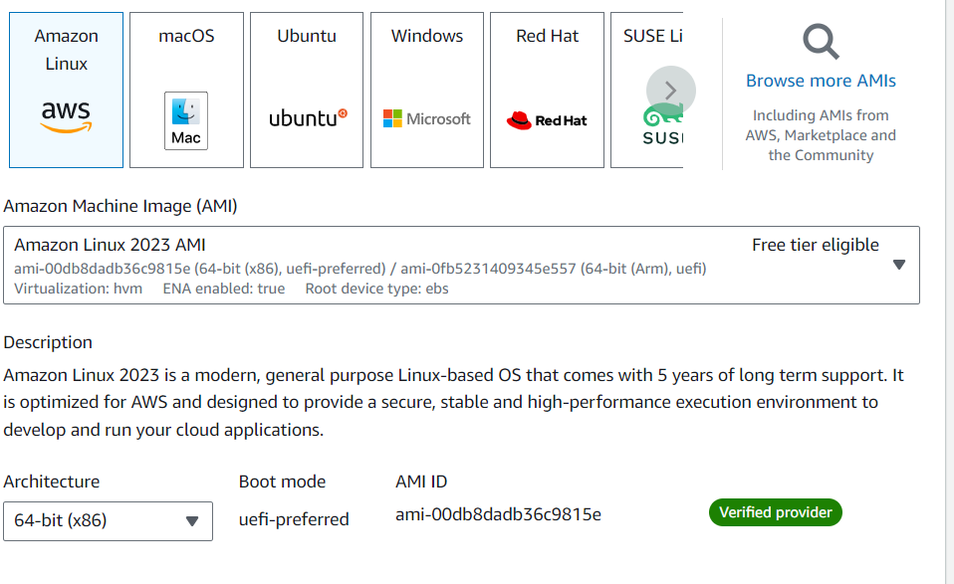

1. **Terraform init:**

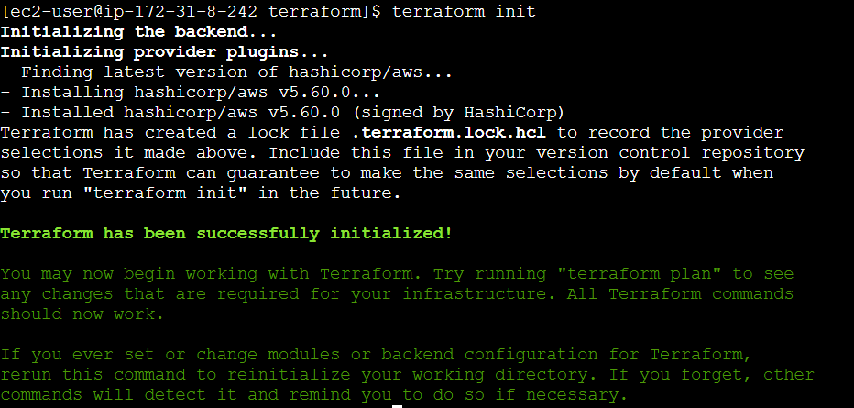

1. **Aws cli configure:**

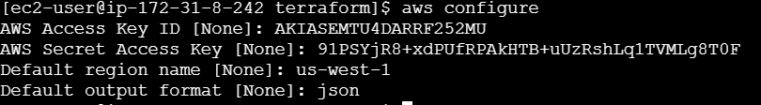

1. **Terraform paln:**

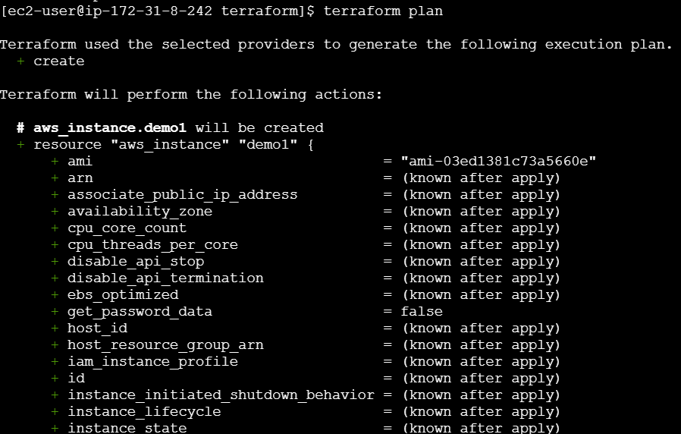

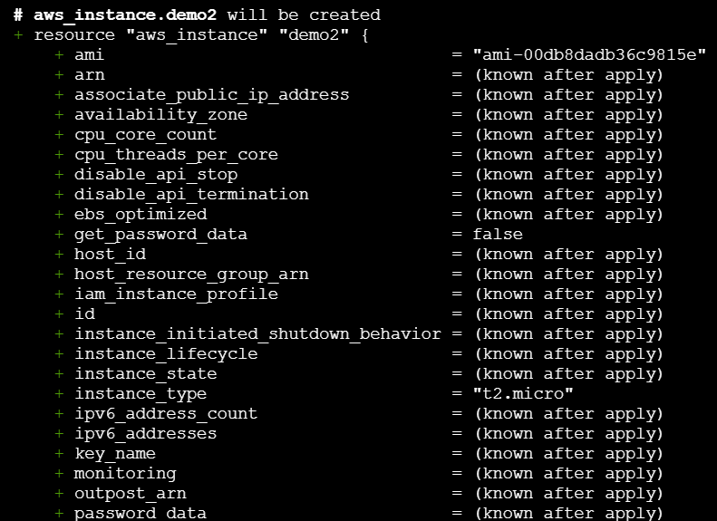

1. **Terraform apply:**

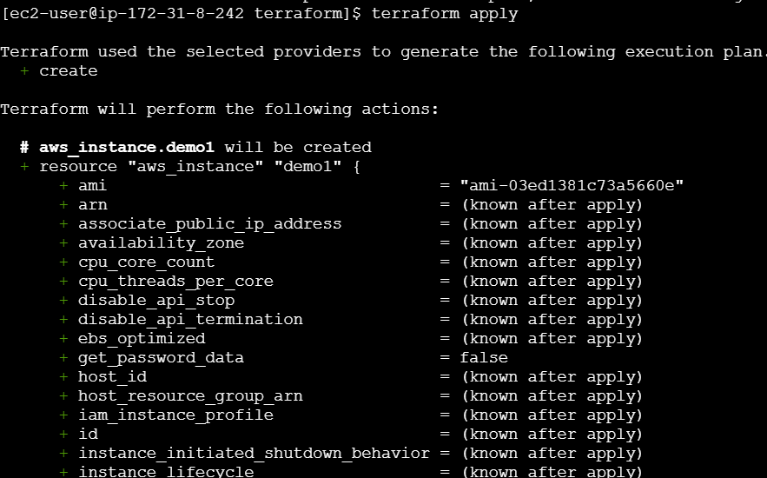

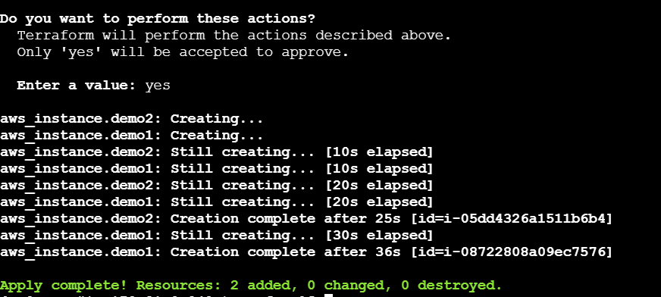



1. **Ec2 created in region us-west-1:**

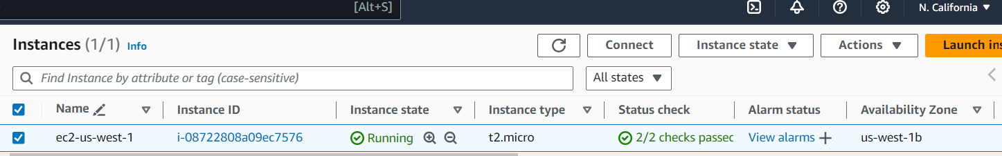

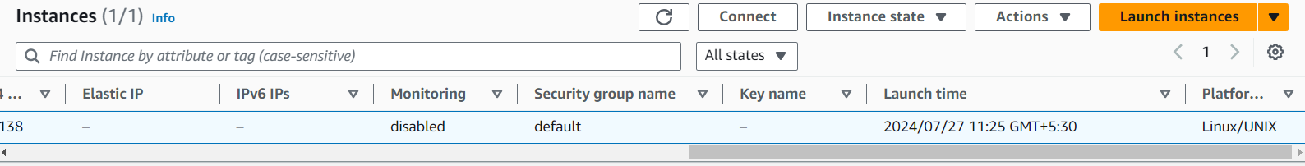

1. **Ec2 created in region us-east-2:**

